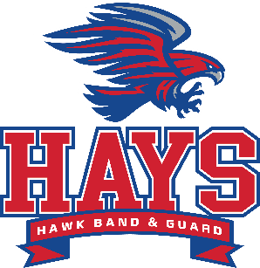

Hays Booster April Meeting Minutes:

-Meeting called to order at 6: 33pm by Lena
-March minutes read by Christina. Approved by Maddie B.
-Mulch: After action report. Some deliverers didn’t follow delivery directions and change date to be before spring break.
$6,547.00 in profits
-Banquet: 4/18 deadline to buy tickets. 193 tickets sold so far. Doors open at 6pm. Need volunteers for set up at 4:30
Senior pictures are needed
Show Reveal before banquet
-Guard: Friends and Family night was amazing. 293 tickets sold and $1,956 in profits
Made finals at State and finished 9th out of 40 schools. They moved up 2 classes and this was their best year
Auditions @ end of the month. 35 in next year’s class
Financials: Open accounts and moved to United Heritage.
A few amendments that were left out from last month’s meeting. Melissa Sanchez 1st, Maddie 2nd. All yays-approved
Directors: 1st day of Auditions for BLT today
UIL: all 3 bands got Sweepstakes. Only school in District to do that.
Wind Ensemble to compete
Jazz Band- Austin Jazz Festival Friday hosted by Anderson H.S.
Playing for the Grand opening of the Anthem neighborhood April 23rd
Percussion- Next Monday- Night of Percussion at 7pm at the PAC
Band Audition music for next year to go out soon

Meeting Adjourned at 7:35

